File permissions in Linux

Project description

As a security professional working alongside our research team, my mission was to ensure that our file system wasn’t a "leaky bucket." We had a situation where the actual file permissions didn't align with our official authorization levels. I stepped in to bridge that gap, ensuring that sensitive project data was only accessible to those who truly needed it.

Check file and directory details
The following code demonstrates how I used Linux commands to determine the existing permissions set for a specific directory in the file system.

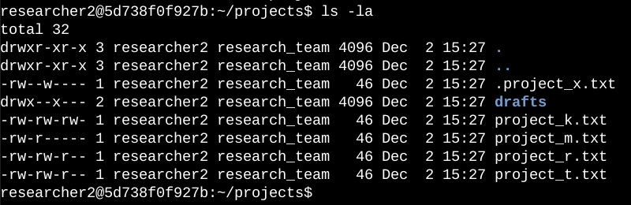

The first line of the screenshot displays the command I entered, and the other lines display the output. The code lists all contents of the projects directory. I used the ls command with the -la option to display a detailed listing of the file contents that also returned hidden files. The output of my command indicates that there is one directory named drafts, one hidden file named .project_x.txt, and five other project files. The 10-character string in the first column represents the permissions set on each file or directory.

Describe the permissions string
The 10-character string can be deconstructed to determine who is authorized to access the file and their specific permissions. The characters and what they represent are as follows:
- 1st character: This character is either a d or hyphen (-) and indicates the file type. If it’s a d, it’s a directory. If it’s a hyphen (-), it’s a regular file.
- 2nd-4th characters: These characters indicate the read (r), write (w), and execute (x) permissions for the user. When one of these characters is a hyphen (-) instead, it indicates that this permission is not granted to the user.
- 5th-7th characters: These characters indicate the read (r), write (w), and execute (x) permissions for the group. When one of these characters is a hyphen (-) instead, it indicates that this permission is not granted for the group.
- 8th-10th characters: These characters indicate the read (r), write (w), and execute (x) permissions for other. This owner type consists of all other users on the system apart from the user and the group. When one of these characters is a hyphen (-) instead, that indicates that this permission is not granted for other.

For example, the file permissions for project_t.txt are -rw-rw-r--. Since the first character is a hyphen (-), this indicates that project_t.txt is a file, not a directory. The second, fifth, and eighth characters are all r, which indicates that user, group, and other all have read permissions. The third and sixth characters are w, which indicates that only the user and group have write permissions. No one has execute permissions for project_t.txt.

Change file permissions
The goal was to identify and fix a security oversight where project files were globally writable. Using chmod, write permissions were stripped from the "others" category to ensure data integrity. I determined project_k.txt must have the write access removed for other.

The following code demonstrates how I used Linux commands to do this:

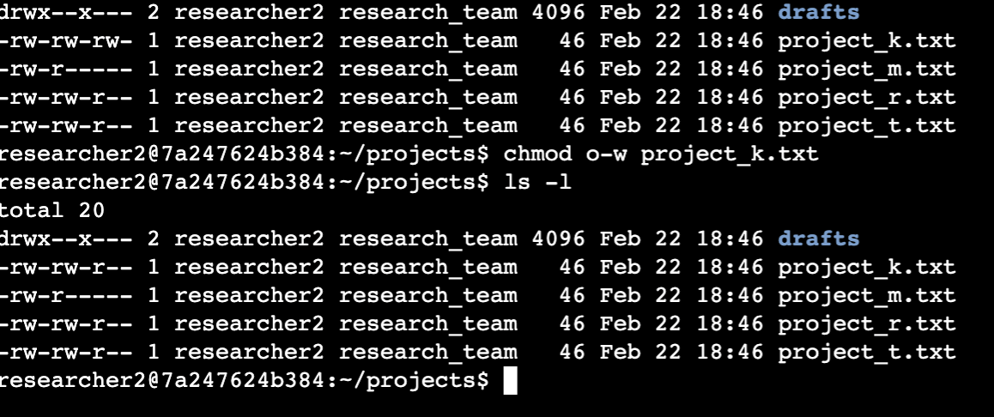

Action Taken:
- Initial Audit: Executed ls -l to identify current file permissions. The file project_k.txt was found to have global write permissions (-rw-rw-rw-).
- Permission Modification: Used the chmod (change mode) command with the argument o-w to specifically remove write permissions from others.
- Verification: Re-ran ls -l to confirm the transition to -rw-rw-r--, ensuring that only the owner and the group retain editing rights.

Change file permissions on a hidden file
The goal was to adjust the security profile of a hidden configuration file by restricting write access for the owner and group while granting read access to the group. This ensures the file remains readable for the team but prevents accidental modifications.

The following code demonstrates how I used Linux commands to change the permissions:

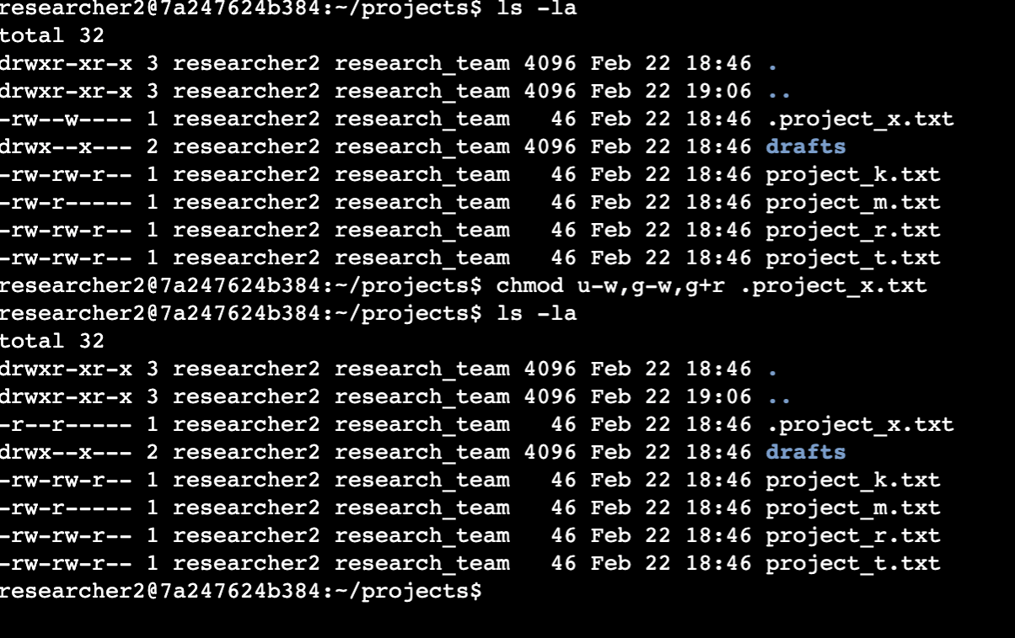

Workflow
- Audit: Ran ls -la to view hidden files. The file .project_x.txt was initially set to -rw--w----.
- Modification: Used chmod u-w,g-w,g+r to perform a multi-class update: removing write access from both the owner and group, and adding read access for the group.
- Verification: Confirmed the change via ls -la, resulting in the updated permission string: -r--r-----.

Change directory permissions
The goal was to isolate the drafts directory so that only the owner, researcher2, maintains access. By removing execute permissions from the group and others, the directory is effectively locked down, preventing anyone else from entering or listing its contents.

The following code demonstrates how I used Linux commands to change the permissions:

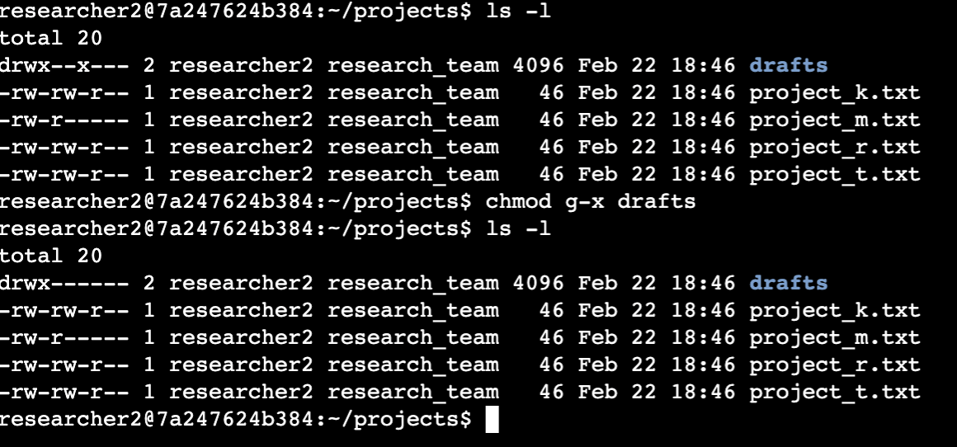

Workflow

Audit: Executed ls -l to check existing directory permissions. The drafts folder was initially set to drwx--x---, allowing group members to execute (enter) the directory.

Hardening: Used chmod g-x drafts to strip the execute bit from the group. Since "others" already lacked permissions, this consolidated access solely to the owner.

Verification: Confirmed the change via ls -l. The directory now reflects drwx------, successfully restricting all access to researcher2 alone.

Summary
This project involved auditing and hardening file security within a Linux environment using the chmod utility. Access was restricted on the project_k.txt file by removing world-write permissions and on the hidden .project_x.txt file by shifting to a read-only group model. Additionally, the drafts directory was isolated by stripping group execute bits to ensure only the owner, researcher2, could access its contents. Systematic verification was performed using ls -la to confirm that the principle of least privilege was strictly enforced across all files.

